- WIDE AREA NETWORK (WAN) AND VPN ASSIGNMENT
Q1. Diagram: Phone Connecting to Instagram Through a WAN
The diagram below shows a simple path followed when a phone on home Wi-Fi communicates with Instagram over the Internet. The exact real Internet path can contain many more routers.
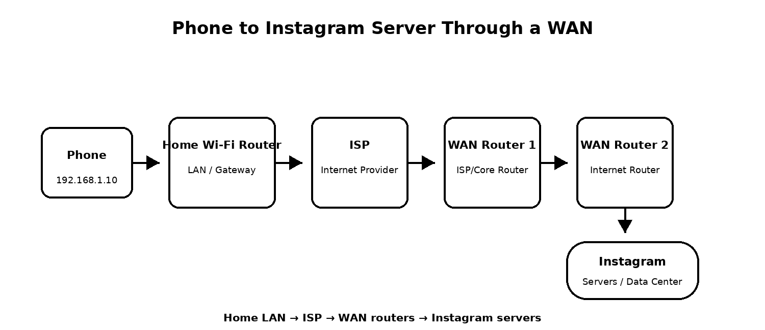
Explanation: The phone first sends data to the home Wi-Fi router. The router forwards it to the ISP. From there, the traffic travels across multiple WAN/core routers on the Internet until it reaches the network hosting Instagram's servers.
Q2. Comparison of Three WAN Technologies
WAN Technology | Typical Speed | Cost | Main Feature | Real-Life Use
MPLS | Depends on provider; commonly Mbps to multi-Gbps | High | Private provider-managed WAN with predictable routing and service levels. | A large company connecting offices, branches or warehouses.
Leased Line | Commonly tens of Mbps to multi-Gbps | High | Dedicated business connection with symmetric bandwidth and service agreement. | Office, data center, bank, ticketing or other business site needing reliable connectivity.
Broadband Internet | Varies widely; commonly tens of Mbps to 1 Gbps+ | Low to Medium | Shared Internet access that is easy and economical to deploy. | Home Wi-Fi, small office, students and general Internet use.

Note: Actual speed and price depend on the ISP, location, service plan and business requirements.
Q3. How a VPN Uses a WAN on Public Wi-Fi
VPN stands for Virtual Private Network. A VPN creates an encrypted tunnel between your device and a VPN server over an existing public network such as coffee-shop Wi-Fi and the Internet (WAN).
- Your phone or laptop first connects to the coffee shop's public Wi-Fi.
- The VPN application creates an encrypted connection to a VPN server across the Internet.
- Your traffic is carried inside this protected tunnel while it crosses the public WAN.
- The VPN server then forwards the traffic toward services such as Spotify or YouTube.
- Encryption helps prevent people on the same local Wi-Fi from easily reading the traffic inside the VPN tunnel.
A VPN improves privacy and security on an untrusted network, but it does not make a device completely safe. Users should still use HTTPS, updated software, strong passwords and trusted VPN services.
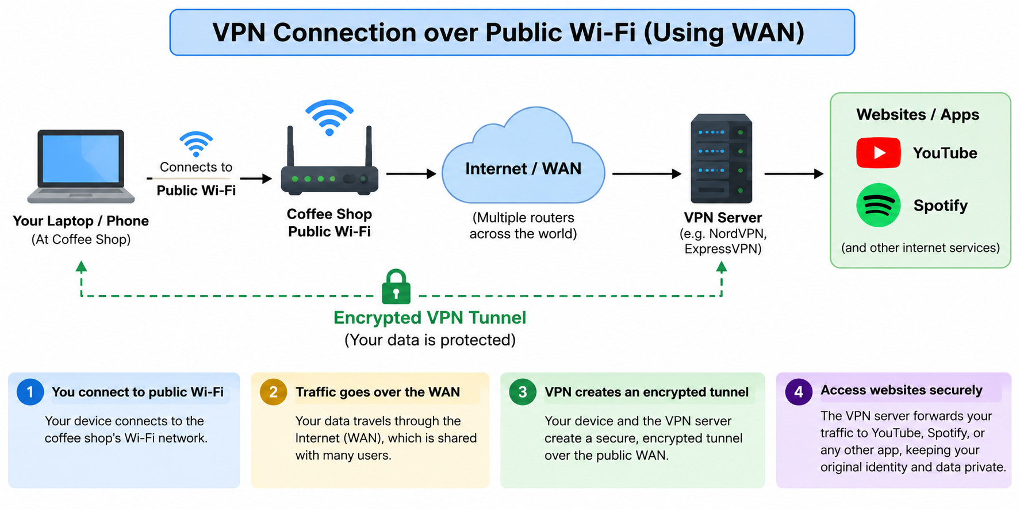
Q4. Best WAN Technology for Flipkart Warehouses
Suggested Technology: MPLS (for the traditional WAN options listed in this assignment)
For a simplified assignment scenario connecting warehouses in Ahmedabad, Mumbai and Delhi, MPLS is a suitable choice when Flipkart wants a provider-managed private WAN between the sites.
Reason 1 - Reliable Multi-Site Connectivity
MPLS is designed to connect multiple business locations through a service provider's network. The three warehouses can communicate as part of one managed WAN instead of treating each site as a completely separate Internet connection.
Reason 2 - Predictable Business Performance
Business MPLS services can provide service-level agreements and traffic prioritization. This is useful for important warehouse traffic such as inventory systems, internal applications and communication between locations.
Practical note: Modern companies may also choose SD-WAN over multiple Internet/leased connections because it can provide flexibility and redundancy. The final choice depends on cost, required availability, cloud usage and the telecom services available at each warehouse.
Conclusion
WAN technologies connect devices and networks across large geographical areas. Home broadband provides economical Internet access, leased lines provide dedicated business connectivity, and MPLS can connect multiple company locations through a managed WAN. VPNs add an encrypted tunnel over a public WAN to improve security when using untrusted networks.

